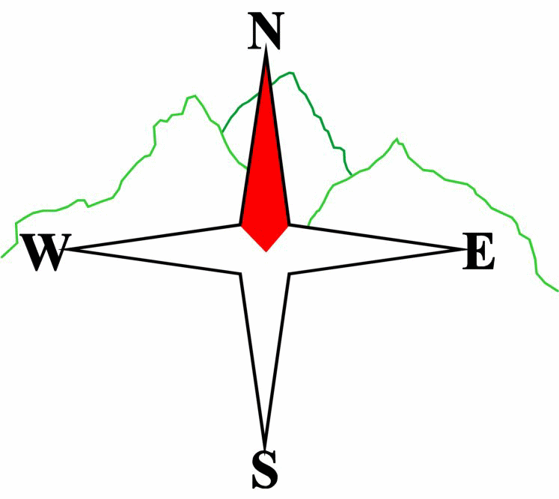***Blairgowrie & District Hillwalking Club***

**www.bdhc.org.uk**

**Amulree**

**03/03/2024**

**O.S. Map No**: 52

|  |  |  |  |  |
| --- | --- | --- | --- | --- |
| **Car times:** | **Alyth** (**Square**): **07.45 am** | | **Blairgowrie (Wellmeadow)** **: 08.00am**  **Dunkeld: 08.20am** | |
| A Walk – Meall Nam Fuaran 805m | | | | |
| From Amulree village hall, NN 898 363, follow Kenmore road to Croftmill, then turn left onto Rob Roy Way (RRW). At 822 343 turn right onto Glen Shervie track. Turn right again at 813 355 on track heading NE up Meall Nam Fuaran. From summit head E to join track leading back to RRW. | | | | |
| Approx. distance: 22 km | | Total ascent: 725 m | | Min. **walking** time: 6¾ hrs |
|  | | | | |
| B Walk – Meall Dearg 690m and Creag An Loch 663m | | | | |
| Head N on A822, cross old road bridge and at NN 902 368 pick up track heading NE by farm buildings. Head NNE on the straight Old Military Road. It turns NNW over the Glenfender Burn to meet the Glen Fender track running NW at 908 384. At 893 392 turn right onto track leading uphill northwards to Beinn Liath, then NNW to Meall Dearg 690m. Head SW to Creag An Loch 663m then SW to join track descending SW to Glen Quaich, then SE on RRW by Loch Freuchie back to Amulree. | | | | |
| Approx. distance: 18 km | | Total ascent: 620 m | | Min. **walking** time: 5½ hrs |
| |  | | --- | |  | | B & C Walk – Bridge Of Cally to Blairgowrie |  |  |  |  | | --- | --- | --- | | Join Cateran Trail at Bridge of Cally. Same route as A walk from NO 147 483. | | | | Approx. distance: 14 km | Total ascent: 224 m | Min. **walking** time: 4 hrs | | | | | |  | Min. **walking** time: 5.25 hrs |
| C Walk – Glen Fender & Glen Quaich | | | | |
| Start as B Walk. At track junction 907 373 head NWW passing to N of Craig Hulich. Continue NW on track until junction at 882 388. Then climb N to keep S of 608m spot height before descending SW to Glen Quaich. Take RRW SE by Loch Freuchie to return to Amulree. (NB: This walk is all on tracks - not all on OS 1:50) | | | | |
| Approx. distance: 14 km | | Total ascent: 430 m  **Please note that the Minimum walking times are based on reasonably fast walkers and assuming good conditions. The times do not include stops or breaks.** **In poor weather conditions or if members are not comfortable walking at 4km/hour then alternative or shorter routes should be considered. Experienced members may devise their own routes (min 3 walkers) but must inform the Meet Sec and return to the end point at the agreed time.** | | Min. **walking** time: 5¼ hrs (@3kph) |

Next club walk – Meall Chuaich on Sunday 24th March, 8am Wellmeadow

Other events: Mountain Mind Quiz Tuesday 12th March, AGM Friday 29th March, both at Golf Club

|  |  |
| --- | --- |
| IMPORTANT: YOUR SAFETY IN THE HILLS | |
| **The Committee reminds members and guests of the following important points:** | |
| * You are responsible for your own safety * Club officials are not trained mountain leaders * Are you fit enough to complete your chosen walk in the available time? * Know where you are going on the walk and follow the route on your map. * Know how many are in your party and stay together | * Ensure you have enough food plus emergency rations * Carry a map & compass, survival bag, torch, whistle and small first aid kit. Know how to use them. * In winter conditions you must carry an ice axe on high level walks (club rule). You are also recommended to carry crampons. * **Learn** how to use your equipment. |
|
|
|
|
|  |
| **Club officials will be happy to give advice on any of these points if requested.** | |