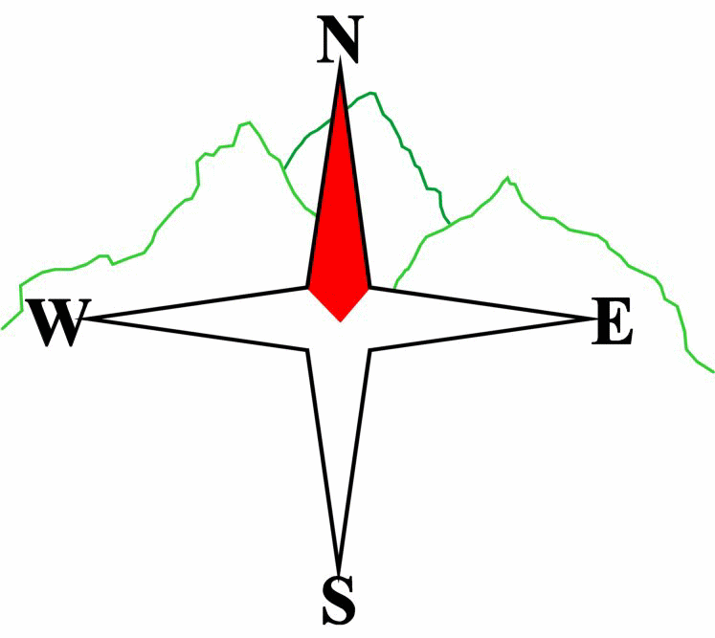***Blairgowrie & District Hillwalking Club***

**www.bdhc.org.uk**

Glen Dochart - Meall Glas

**01/09/2024**

**O.S. Map No**: 51

|  |  |  |  |  |
| --- | --- | --- | --- | --- |
| **Bus times:** | **Blairgowrie** (**Wellmeadow**): **07:30** | | **Alyth** (**Square**): **07:15** | |
|  | **Other: Perth (Tesco, Crieff Rd) 07:50** | | | |
|  | | | | |
| A Walk – Meall Glas & Sgiath Chuil | | | | |
| Start from grassy car park at (NN 448 276) at side of A85. Take track north over the river past Auchessan. There is then a track heading north for app 1km. After head in the direction of the outcrop at (433 317) passing it to its west and then northwards onto Meall Glas (**M** 959m). Head E then NE along the ridge to Ben Cheathaich. Walk N for c200 m before dropping E into the bealach and steeply E to the ridge onto Meall a Churain. Head S to Sgaith Chuil (**M** 919m) and thence on to Sgiath Chrom. Head in a SW direction towards the N tip of a plantation (450 298). Follow its W edge and meet the track end at (444 292) and back to the start. | | | | |
| Approx. distance: 16.3 km | | Total ascent: 1299 m | | Min. **walking** time: 7 ¼ hrs |
| A2 Walk – Beinn nan Imerian & Meall Glas Follow A walk to point around (440 305) then head due W to the little outlier Meall Garbh (429 305). From here walk NW to Beinn nan Imerian (**C** 849m), From the summit walk NE to Meall Glas (M 959m) From there return to start reversing the outward A Walk route to the summit.  Approx distance: 13.5 km Total ascent: 997 m Min **walking** time: 4 ¾ hrs | | | | |
| B Walk – Meall Glas | | | | |
| As the A Walk to the summit, retracing the route back to the start. | | | | |
|  | | | | |
| Approx. distance: 11.4 km | | Total ascent: 796 m | | Min. **walking** time: 4 ¼ hrs |
|  | | | | |
| C Walk – Glen Ogle Railway Viaducts | | | | |
| Start at toilets carpark on A85 on entering Lochearnhead at NN 593 238. Take road behind carpark in NW direction to meet old railway line and follow this over viaduct for about 200ms to the A 85. Cross road and up steep slope to join old railway line going in a northerly direction. Follow this for 5km over the viaducts to a point where it crosses the A85 at 558 284. Take the track from the carpark and in 0.5km turn left at pylons then after another 0.5km keep right and at a junction turn left. On meeting the railway line again turn right to Acharn and Killin. Look out for cyclists as they share these tracks. | | | | |
| Approx. distance: 12 km | | Total ascent: 283 m | | Min. **walking** time: 4 ½ hrs (@3kph) |

**Please note that the Minimum walking times are based on reasonably fast walkers and assuming good conditions. The times do not include stops or breaks.**

## **In poor weather conditions or if members are not comfortable walking at 4km/hour then alternative or shorter routes should be considered.**

The next club walk is on the **13/10/2024** to **Inverey** starting at 08:00 (Blairgowrie) and 07:45 (Alyth).

Other information/events: **Slide Night** 13th September, Golf Club, 7:30 pm. **Autumn Weekend** 20-22 September

|  |  |
| --- | --- |
| IMPORTANT: YOUR SAFETY IN THE HILLS | |
| **The Committee reminds members and guests of the following important points:** | |
| * You are responsible for your own safety * Club officials are not trained mountain leaders * Are you fit enough to complete your chosen walk in the available time? * Know where you are going on the walk and follow the route on your map. * Know how many are in your party and stay together | * Ensure you have enough food plus emergency rations * Carry a map & compass, survival bag, torch, whistle and small first aid kit. Know how to use them. * In winter conditions you must carry an ice axe on high level walks (club rule). You are also recommended to carry crampons. * **Learn** how to use your equipment. |
|
|
|
|
|  |
| **Club officials will be happy to give advice on any of these points if requested.** | |