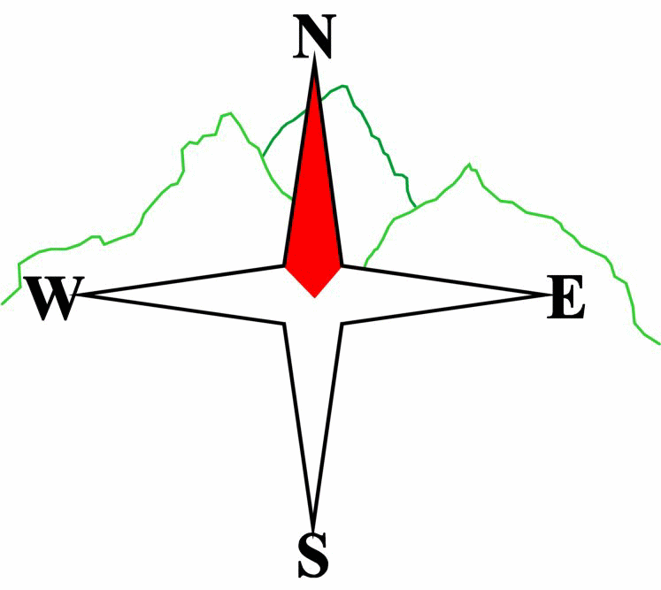***Blairgowrie & District Hillwalking Club***

**Web site: www.bdhc.org.uk**

Farragon Hill

**OS 52**

03/11/24

|  |  |  |  |  |
| --- | --- | --- | --- | --- |
| **Bus start:** | **Blairgowrie** (**Wellmeadow**): **08:00 am**  **Other (Birnam): 08:15** | | **Alyth** (**Square**): **07:45 am** | |
|  | | | | |
| A Walk – Meall Tairneachan and Farragon Hill | | | | |
| Start NN 780 562 and take track SE towards mines. Climb up to summit of **Meall Tairneachan (C 780m)** Keep on track past mines heading Eastwards then over rougher ground to summit of **Farragon Hill (C 783m)**. Head E to pick up track and then follow this SE to Loch Derculich. Keep heading WSW on this track to Lurgan. Here keep on the track to the right of the B&B farmhouse and polytunnels. Stay on this main track heading generally S and make way down tarmac drive to meet the B846. Turn left on this road and walk for approx 3.5km to Strathtay. Cross bridge into Grandtully to meet bus. | | | | |
| Approx. distance: 21 km | | Total ascent: 840 m | | Min. **walking** time: 6 1/2 hrs |
|  | | | | |
| B Walk – Dull to Weem by Loch Farleyer | | | | |
| Start at NN 803 488 and walk into Dull. Take path eastwards to Camserney where at 816495 turn left on good forestry tack. N uphill then trending Eastwards. At first main junction 821 498 turn left on track and follow this WNW then N to Loch Farleyer. After visiting the loch continue on the track heading NE to a signposted track at 820 525. Here turn right downhill to the S till it joins a good track in forest at 836 516. Keep S for nearly 2km till signpost on left at 845 505 for Weem Rock. If time follow narrow path to visit viewpoint at 847 504 but return to this signpost. *Go E through wall and N parallel with this wall for about 200ms then descend E on path 200ms through woodland to track at 848 508. Turn left up to Glassie Bunkhouse. Keep on main track E then S downhill to the road at Cuil. Turn right along B846 road and after 150m on left cross the bridge over the Tay and walk into Aberfeldy. | | | | |
| Approx. distance: 17 km | | Total ascent: 510 m | | Min. **walking** time: 5 hrs |
|  | | | | |
| C Walk – Traverse from Dull to Weem along the escarpment Start as B party at NN 803 488 and walk into Dull looking at historic church. Take path eastwards to Camserney where at 816 495 turn left uphill on good forestry track N then trending eastwards. At first main junction 821 498 keep straight on to Shenavail. Pass through gates beyond Shenavail to follow track past Rawer ruins and ignoring other smaller paths keep on to meet forestry track and continue eastwards. After 100ms 845 505 turn right on path signed to Weem Rock. Return to sign and follow route as for B walk from *. | | | | |
|  | | | | |
| Approx. distance: 11 km | | Total ascent: 350 m | | Min. **walking** time: 4 ½ hrs (at 3 kph) |

**Please note that the Minimum walking times are based on reasonably fast walkers and assuming good conditions. The times do not include stops or breaks.**

## **In poor weather conditions or if members are not comfortable walking at 4km/hour then alternative or shorter routes should be considered.**

## The next club walk is using **cars** on the **24/11/24** to **Ben Gulabin** starting at 8:00 am (Blairgowrie) .

## **15/12/24 Xmas Walk** – Glen Isla (Auchintaple Loch to Loch Shandra) 9:00 am.

|  |  |
| --- | --- |
| IMPORTANT: YOUR SAFETY IN THE HILLS | |
| **The Committee reminds members and guests of the following important points:** | |
| * You are responsible for your own safety * Club officials are not trained mountain leaders * Are you fit enough to complete your chosen walk in the available time? * Know where you are going on the walk and follow the route on your map. * Know how many are in your party and stay together | * Ensure you have enough food plus emergency rations * Carry a map & compass, survival bag, torch, whistle and small first aid kit. Know how to use them. * In winter conditions you must carry an ice axe on high level walks (club rule). You are also recommended to carry crampons. * **Learn** how to use your equipment. |
|
|
|
|
|  |
| **Club officials will be happy to give advice on any of these points if requested.** | |