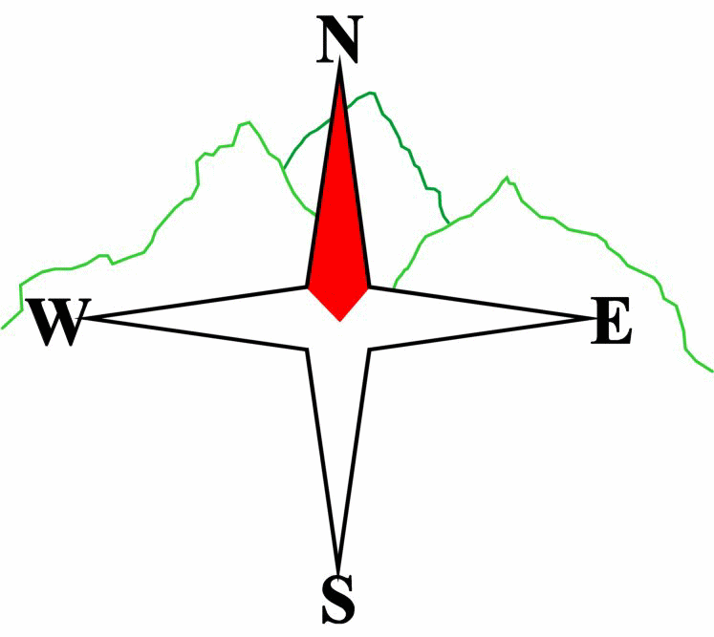***Blairgowrie & District Hillwalking Club***

**www.bdhc.org.uk**

**Glen Isla Xmas Walk**

**15/12/2024**

**O.S. Map No**: 43 & 44

|  |  |  |  |  |
| --- | --- | --- | --- | --- |
| **Bus times:** | **Blairgowrie** (**Wellmeadow**): **09:00 am** | | **Alyth** (**Square**): **09:45 am** | |
|  |  | | | |
|  | | | | |
| All Walkers – Loch Auchintaple & Loch Shandra | | | | |
| Start on Cateran Trail just S of Forter Bridge in Glen Isla at NO 187 648. Walk NE uphill. After 700ms turn right to leave Cateran Trail on a good track SE to fishing hut by Loch Auchintaple . Keeping to lochside go through two sets of gates and over dam wall to small wooden bridge. Cross this and follow track uphill to meet Cateran Trail again. Turn left and keep on Trail uphill to 203 654. Do not cross stile but leave Trail by turning SE on a narrow path to spot height 455 on S ridge of Badandun Hill and on southwards to Craighead. Here pick up a better track going NW then SW onto Cateran Trail again. Turn left in SE direction on Trail and follow this past Loch Shandra and eventually on to main Glen Isla Road. Turn right to walk past Glen Isla Hotel to public carpark just beyond on left to meet coach which will transport us to the Alyth Hotel for Xmas refreshments. | | | | |
| Approx. distance: 12 km | | Total ascent: 260 m | | Min. **walking** time: 3 ½ to 4 hrs |
|  | | | | |
|  | | | | |
|  | | **Please note that the Minimum walking times are based on reasonably fast walkers and assuming good conditions. The times do not include stops or breaks.** **In poor weather conditions or if members are not comfortable walking at 4km/hour then alternative or shorter routes should be considered.** | |  |
|  | | | | |
|  | | | | |
|  | | | | |
|  | |  | |  |

|  |  |
| --- | --- |
| IMPORTANT: YOUR SAFETY IN THE HILLS | |
| **The Committee reminds members and guests of the following important points:** | |
| * You are responsible for your own safety * Club officials are not trained mountain leaders * Are you fit enough to complete your chosen walk in the available time? * Know where you are going on the walk and follow the route on your map. * Know how many are in your party and stay together | * Ensure you have enough food plus emergency rations * Carry a map & compass, survival bag, torch, whistle and small first aid kit. Know how to use them. * In winter conditions you must carry an ice axe on high level walks (club rule). You are also recommended to carry crampons. * **Learn** how to use your equipment. |
|
|
|
|
|  |
| **Club officials will be happy to give advice on any of these points if requested.** | |

The next club walk is on the **05/01/2025** to **Sidlaws** starting at 09:00 am (Blairgowrie) and 08:45 am (Alyth).

Other information/events: **Twixt meet to Aviemore.** For more information contact the meet secretary.