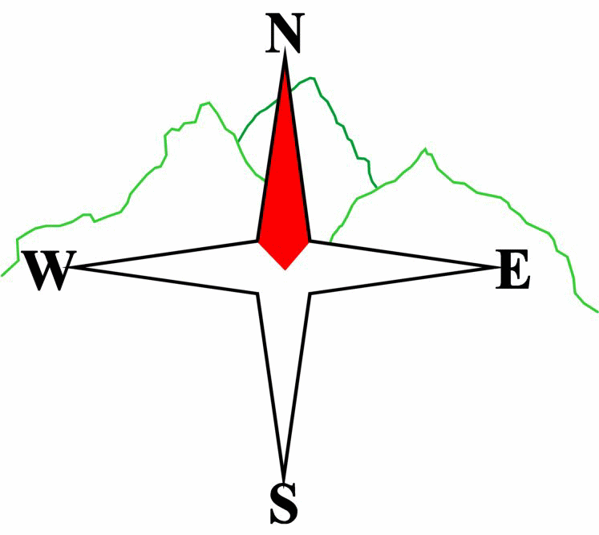***Blairgowrie & District Hillwalking Club***

**www.bdhc.org.uk**

**South Loch Tay**

**09/03/2025**

**O.S. Map No**: 52

|  |  |  |  |  |
| --- | --- | --- | --- | --- |
| **Meeting :** | **Blairgowrie** (**Wellmeadow**): **08:00** | | **Alyth** (**Square**): **07:45** | |
| **times :** | **Other Place: TBA** | | | |
| **Transport:** | **CARS** | | | |
|  | | | | |
| A Walk – Creagan na Beinne | | | | |
| Start Acharn NN 755 438. Take track on W side of burn to Falls of Acharn. Continue S uphill to junction with path at 754 416. Take this SSW then W until it reaches the NE spur of Beinn Bhreac 744 407. Turn SSW and climb this spur to reach a bealach at 738 397. Follow the ridge southwards to reach the summit of **Creagan na Beinne** **C 888 m**. Return northwards to bealach at 741 391. Descend just N of E to track which can be followed back to the start. | | | | |
| Approx. distance: 19 km | | Total ascent: 840 m | | Min. **walking** time: 6 ¼ hrs |
|  | | | | |
| B Walk – Kenmore Hill, Creag an Sgliata & Meall a’ Choire Chreagaich circuit | | | | |
| Start in forest carpark off the Kenmore-Amulree road NN 786 446.Follow the way marked route to the summit of **Creag an Fhudair (Kenmore Hill)**. Continue downhill on waymarked route to meet the Rob Roy Way. Go westwards until a track junction at 767 431. Take track S to junction at 769 419 then the open hill past grouse butts to reach the summit of **Creag an Sgliata 697 m**. Go NE mostly in open country to reach **Meall a’ Choire Chreagaich 665 m**. Descend NE to reach the minor road which follow downhill to the start. | | | | |
| Approx. distance: 16 km | | Total ascent: 825 m | | Min. **walking** time: 5 ¼ hrs |
|  | | | | |
| C Walk – Creag an Fhudair (Kenmore Hill) and Falls of Acharn circuit | | | | |
| Park cars at Courtyard bar just N of the bridge in Kenmore. Walk back through Kenmore and up the Amulree Road to NN 787 447. Turn right past carpark to follow the red waymark signs to the top of **Creag an Fhudair (Kenmore Hill)**. Continue on the path downhill, still following the red signs, NW then northwards to meet the Rob Roy Way. Turn left and follow this track to the Falls of Acharn where it descends to the road. Turn right and walk back into Kenmore and the start. This route can be shortened by 2km if required by leaving the Rob Roy Way at Balmacnaughton and descending to the lochside road at Remony. | | | | |
| Approx. distance: 14 km | | Total ascent: 525 m | | Min. **walking** time: 5 ¼ hrs (@ 3kph) |

Depending on when groups get off the hill, we can meet up at the **Courtyard bar in Kenmore** for refreshments.

Template revision: 2024-12-03

The next club walk is on the **30/03/2025** to Fife coastal walk starting at 09:00 (Blairgowrie) and 08:45 (Alyth).

Other information/events**: 28/03/25 AGM at Blairgowrie Golf Club 19:00 (7 pm)**

**Please note that the Minimum walking times are based on reasonably fast walkers and assuming good conditions. The times do not include stops or breaks.**

## **In poor weather conditions or if members are not comfortable walking at 4km/hour then alternative or shorter routes should be considered.**

|  |  |
| --- | --- |
| IMPORTANT: YOUR SAFETY IN THE HILLS | |
| **The Committee reminds members and guests of the following important points:** | |
| * You are responsible for your own safety * Club officials are not trained mountain leaders * Are you fit enough to complete your chosen walk in the available time? * Know where you are going on the walk and follow the route on your map. * Know how many are in your party and stay together | * Ensure you have enough food plus emergency rations * Carry a map & compass, survival bag, torch, whistle and small first aid kit. Know how to use them. * In winter conditions you must carry an ice axe on high level walks (club rule). You are also recommended to carry crampons. * **Learn** how to use your equipment. |
|
|
|
|
|  |
| **Club officials will be happy to give advice on any of these points if requested.** | |