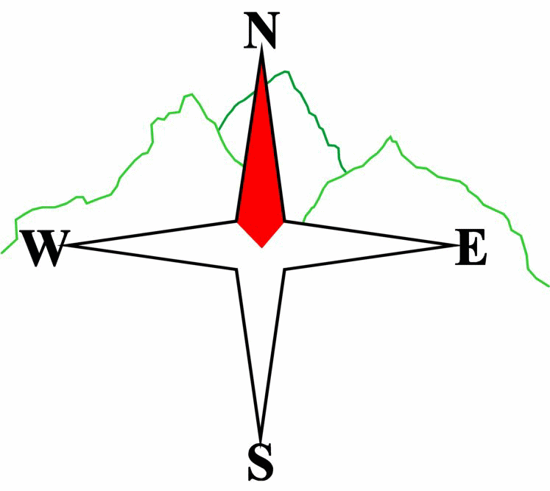***Blairgowrie & District Hillwalking Club***

**Web site: www.bdhc.org.uk**

**Rannoch Station to Kings House**

**Map 41 & 42**

**Saturday 2nd August 2025**

|  |  |  |  |  |
| --- | --- | --- | --- | --- |
| **Bus start:** | **Blairgowrie** (**Wellmeadow**): **08:00**  **Other:** | | **Alyth** (**Square**): **07:45** | |
|  | | | | |
| A Walk – Stob na Cruaiche (Graham) | | | | |
| Catch the 10:21hrs train from Crianlarich to Rannoch Station arriving c. 11:08.  Start at Rannoch Station NN 423 578 and cross the railway line by the level crossing past the cottage. Take the track N at 418 579 to gain the open hillside and follow a vague ATV track westwards up the ridge to Meall a’ Bhuirich (638m) and on to the summit of Stob na Cruaiche (**G** **739m**). Continue W over Stob nan Losgann to col at 402m then follow track over Meall a’Phuill to Black Corries Lodge and on to Kings House hotel. Turn left to take road to Ski centre carpark and bus. | | | | |
| Approx. distance: 23 km | | Total ascent: 620 m | | Min. **walking** time: 6¾ hrs |
|  | | | | |
| B Walk – Loch Laidon Track | | | | |
| Start at Rannoch Station. Cross the railway line as A walk but at 418 579 take the lower track which enters the forest. Follow this track through the forest and continue W past Black Corries Lodge to Kings House hotel. Turn left to take road to Ski centre carpark and bus. | | | | |
| Approx. distance: 22 km | | Total ascent: 260 m | | Min. **walking** time: 6 hrs |
|  | | | | |
| C Walk – Loch Ossian and Meall na Lice (584m) Remain on train till Corrour station, c.11:21. From station NN 356 664 take the track NE to the turn-off for the YH. Here turn SE onto a path going S to Lubnaclach. After c. 500 m, plot a route E to the summit of Meall na Lice (584 m) avoiding crags on its N side. Descend Southwards down the shoulder to meet a path/track at 386 654, west of the Allt a Choire Odhar Bhig. Follow this Eastwards to meet a main track going N to Peter’s Rock. Turn W back to the station. (A longer alternative would be the Loch Ossian circuit on good tracks.)  Approx. walking distance: 12.3 km (15 km) Total ascent: 350 m (85 m) Min. **walking** time: 4½ hrs (5¼ hrs) @ 3kph  Board the 18.25 train to Tyndrum arriving 19.16 to meet with A & B parties for a meal. | | | | |
|  | | | | |

|  |  |
| --- | --- |
| IMPORTANT: YOUR SAFETY IN THE HILLS | |
| **The Committee reminds members and guests of the following important points:** | |
| * You are responsible for your own safety * Club officials are not trained mountain leaders * Are you fit enough to complete your chosen walk in the available time? * Know where you are going on the walk and follow the route on your map. * Know how many are in your party and stay together | * Ensure you have enough food plus emergency rations * Carry a map & compass, survival bag, torch, whistle and small first aid kit. Know how to use them. * In winter conditions you must carry an ice axe on high level walks (club rule). You are also recommended to carry crampons. * **Learn** how to use your equipment. |
|
|
|
|
|  |
| **Club officials will be happy to give advice on any of these points if requested.** | |

**Please note that the Minimum walking times are based on reasonably fast walkers and assuming good conditions. The times do not include stops or breaks.**

## **In poor weather conditions or if members are not comfortable walking at 4km/hour then alternative or shorter routes should be considered.**

## The next club walk is on the 24th August to Glen Feshie starting at 7.30 am (Blairgowrie) and 7.15 am (Alyth).

Other information/events: 9th August BBQ at Roddy’s . Further details TBA.