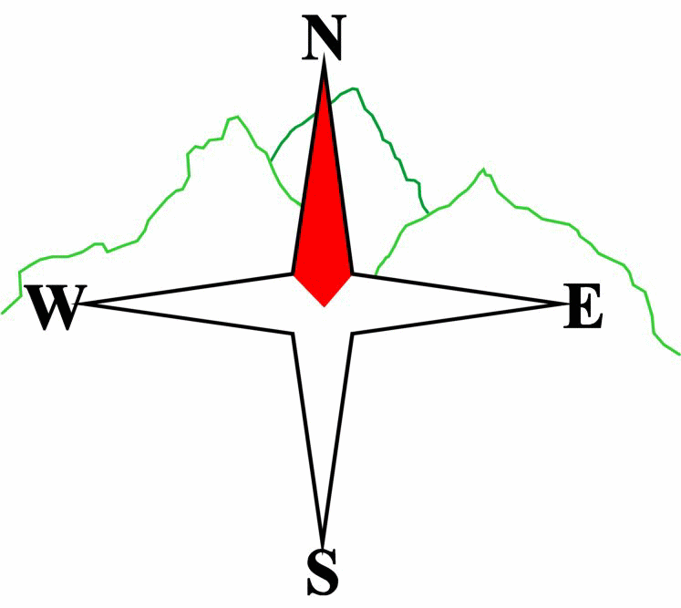***Blairgowrie & District Hillwalking Club***

**www.bdhc.org.uk**

**Ben More & Stob Binnien**

**13/07/2025**

**O.S. Map No**: 51

|  |  |  |  |  |
| --- | --- | --- | --- | --- |
| **Bus times:** | **Blairgowrie** (**Wellmeadow**): **07.30 am** | | **Alyth** (**Square**): **07.15 am** | |
|  |  | | | |
|  | | | | |
| A Walk – Ben More & Stob Binnien | | | | |
| Start at NN 414 259 and follow the path as it zig-zags up Ben More’s NW ridge. The steep angle of the path eases a little as it approaches the summit (**M 1174m**). From the summit descend S to reach the bealach before climbing in the same direction to reach the summit of Stob Binnien (**M 1165m**). Retrace steps northward to the bealach then head west steeply down towards the floor of Benmore Glen, there picking up a path that eventually meets the outward path and returns to the start. | | | | |
| Approx. distance: 12 km | | Total ascent: 1340 m | | Min. **walking** time: 5 ¼ hrs |
|  | | | | |
| B Walk – Ben More | | | | |
| Start as the A Walk and follow its route to the summit of Ben More. Head south from the summit and follow the A Walk route down into Benmore Glen and back to the start. (Alternatively leave the summit and head down the hill’s rocky NE ridge, After c1.5 kms, traverse in a westerly direction across the trackless hillside to eventually meet the upward path). | | | | |
| Approx. distance: 9 km (7 km) | | Total ascent: 1050 m | | Min. **walking** time: 4 hrs (3 ½ hrs) |
|  | | | | |
| C Walk – WHW from Tyndrum to Crianlarich | | | | |
| Start at NN 330 303 and walk SW to meet the WHW near Tyndrum’s station. Stay on the well-walked route, trending south east as it follows Strath Fillan on mixed terrain. It passes the ruins of St Fillan’s chapel and before that, at Dalrigh, the King’s Field, where Robert the Bruce suffered a rare defeat at the hands of the MacDougalls of Lorne. Leave the trail at 376 251 and take the path east to Crianlarich. | | | | |
| Approx. distance: 11 km | | Total ascent: 250 m | | Min. **walking** time: 4 hrs (@3km/hr) |

The next club walk is on **Sat** **2nd August,** Rannoch Stn to Kingshouse starting at tbc am (Blairgowrie) and tbc am (Alyth).

Other information/events: **Sat 9th August** Club BBQ at Roddy’s

**Please note that the Minimum walking times are based on reasonably fast walkers and assuming good conditions. The times do not include stops or breaks.**

## **In poor weather conditions or if members are not comfortable walking at 4km/hour then alternative or shorter routes should be considered.**

|  |  |
| --- | --- |
| IMPORTANT: YOUR SAFETY IN THE HILLS | |
| **The Committee reminds members and guests of the following important points:** | |
| * You are responsible for your own safety * Club officials are not trained mountain leaders * Are you fit enough to complete your chosen walk in the available time? * Know where you are going on the walk and follow the route on your map. * Know how many are in your party and stay together | * Ensure you have enough food plus emergency rations * Carry a map & compass, survival bag, torch, whistle and small first aid kit. Know how to use them. * In winter conditions you must carry an ice axe on high level walks (club rule). You are also recommended to carry crampons. * **Learn** how to use your equipment. |
|
|
|
|
|  |
| **Club officials will be happy to give advice on any of these points if requested.** | |