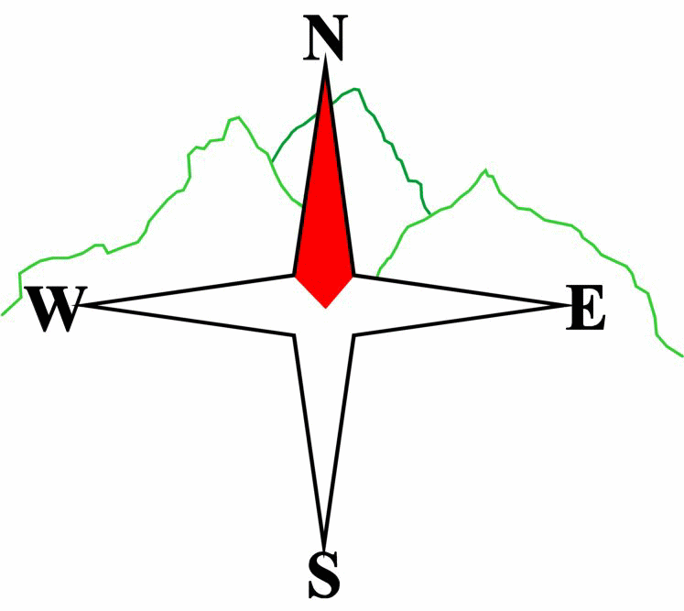***Blairgowrie & District Hillwalking Club***

**www.bdhc.org.uk**

**Trossachs – Ben Venue and Loch Ard**

**12/10/2025**

**O.S. Map No**: 57

|  |  |  |  |  |
| --- | --- | --- | --- | --- |
| **Meeting :** | **Blairgowrie** (**Wellmeadow**): **08:00** | | **Alyth** (**Square**): **07:45** | |
| **times :** | **Other: Perth Park and Ride: 08:25** | | | |
| **Transport:** | **COACH** | | | |
|  | | | | |
| A & B Walks – Ben Venue | | | | |
| Start NN 459 023 at Ledard farm road end on B829 Loch Ard. Take track past the farm. Cross the burn and follow path on W side which crosses back to ascend the hill after c 2.5 km. Continue on path N then NE to the summit of Ben Venue **G 729 m**. Continue ESE for c. 350 m to the trig point for good views to the east. Return on the ascent path to the junction in the bealach at 469 061. Descend southwards into Gleann Riabhach then E and NE until meeting the Great Trossachs Path at 497 060. Take this eastwards through the forest, across the A821 and down to cross the Achray Water on the bridge at 533 064 near the Byre Inn (probably closed!) | | | | |
| Approx. distance: 16 km | | Total ascent: 810 m | | Min. **walking** time: 5½ hrs |
|  | | | | |
| C Walk – Loch Ard | | | | |
| Start Kinlochard NN 455 023 and take the minor road to Blairhullichan and further uphill to meet the cycleway at 451 006. Turn east on this track for about 6kms as it follows the southern side of Loch Ard ( avoiding any turns on the left ) . At 500 014, by some buildings, turn right. Go S for 100ms then turn left onto a track to a carpark. From here a path leads to a bridge over the Duchray Water at 500 009. After crossing, continue on the track eastwards past Lochan Spling to Kirkton and on to meet the coach in Aberfoyle. | | | | |
| Approx. distance: 13 km | | Total ascent: 230 m | | Min. **walking** time: 4¾ hrs (@ 3kph) |

Template revision: 2024-12-03

The next club walk is on the **02/11/2025** to Beinnn a’ Ghlo starting at 08:00 (Blairgowrie) and 07:45 (Alyth).

Other information/events: **Fri 24/10/2025** Club Night – HEADing to Everest with Evelyn Golf Club 7.30pm

**Please note that the Minimum walking times are based on reasonably fast walkers and assuming good conditions. The times do not include stops or breaks.**

## **In poor weather conditions or if members are not comfortable walking at 4km/hour then alternative or shorter routes should be considered.**

|  |  |
| --- | --- |
| IMPORTANT: YOUR SAFETY IN THE HILLS | |
| **The Committee reminds members and guests of the following important points:** | |
| * You are responsible for your own safety * Club officials are not trained mountain leaders * Are you fit enough to complete your chosen walk in the available time? * Know where you are going on the walk and follow the route on your map. * Know how many are in your party and stay together | * Ensure you have enough food plus emergency rations * Carry a map & compass, survival bag, torch, whistle and small first aid kit. Know how to use them. * In winter conditions you must carry an ice axe on high level walks (club rule). You are also recommended to carry crampons. * **Learn** how to use your equipment. |
|
|
|
|
|  |
| **Club officials will be happy to give advice on any of these points if requested.** | |