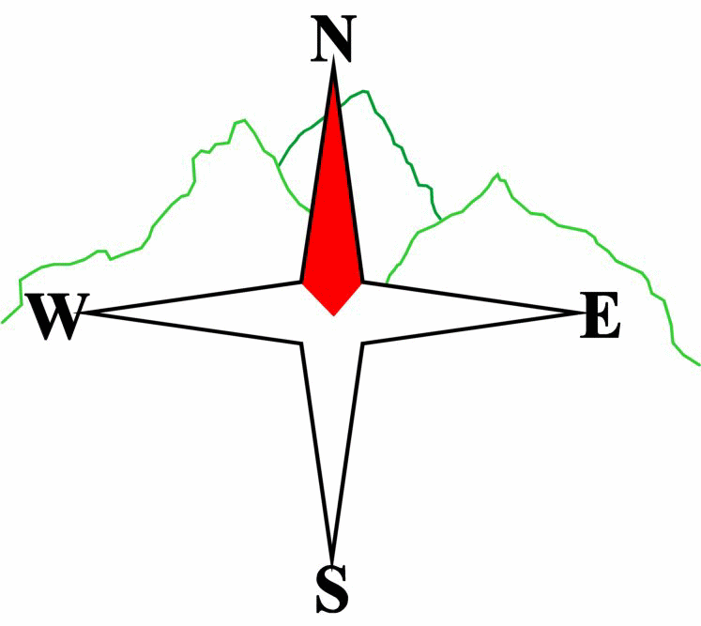***Blairgowrie & District Hillwalking Club***

**www.bdhc.org.uk**

**SOUTHERN CAIRNGORMS**

**04/06/2023**

**O.S. Map No**: **43**

|  |  |  |  |  |
| --- | --- | --- | --- | --- |
| **Bus times:** | **Blairgowrie** (**Wellmeadow**): **07:30 am** | | **Alyth** (**Square**): **07:15 am** | |
|  |  | | | |
|  | | | | |
| A Walk – Bein Bhreac | | | | |
| From Linn of Dee carpark follow path then track N then NW to Derry Lodge. Take path on E side of Derry Burn for approx. 2 km to NO 045952. Take to hill and climb NE to bealach at 055959 then N by E to summit of Beinn Bhreac  (M 931 m). Continue W over West Top and NNW to Craig Derry (865 m). Descend W then southerly down the W ridge of Coire an Fhir Bhogha to the footbridge which crosses the Derry Burn at 040958. (This is the site of a breached dam once used to carry timber in flood water down the glen). Take path on W side of the burn through old pine forest to Derry Lodge. Return to start. | | | | |
| Approx. distance: 19.3 km | | Total ascent: 630 m | | Min. **walking** time: 5 ¾ hrs |
|  | | | | |
| B Walk – Sgor Mor | | | | |
| Take road W for c. 600 m. At edge of plantation strike NNW uphill to Carn an ‘lc Duibhe then NW to Sgor Dubh (741). Continue along ridge eastwards to Sgor Mor (C 813 m). Descend south ridge to path in Glen Dee. Return E to start. | | | | |
| Approx. distance: 16.2 km | | Total ascent: 544 m | | Min. **walking** time: 5 hrs |
|  | | | | |
| C Walk – Red House Bothy and the Chest of Dee | | | | |
| Take good track on N side of River Dee W to White Bridge. (Pieces of the old bridge can be found in the heather showing signs of white paint!) Continue SW to the Geldie ford and the recently restored Red House bothy. In poor weather this could be a good lunch stop. There is a toilet!! Return by same route. On a nice day, the waterfalls at Chest of Dee are worth a detour. | | | | |
| Approx. distance: 16.4 km | | Total ascent: 190 m | | Min. **walking** time: 5 hrs |

The next club walk is on the **25/06/2023** to Northern Cairngorms starting at 07:30 am (Blairgowrie) and 07:15 am (Alyth).

Other information/events: Corrour by train Sat 15th July & Coastal Walk Sat 29th July

**Please note that the Minimum walking times are based on reasonably fast walkers and assuming good conditions. The times do not include stops or breaks.**

## **In poor weather conditions or if members are not comfortable walking at 4km/hour then alternative or shorter routes should be considered.**

|  |  |
| --- | --- |
| IMPORTANT: YOUR SAFETY IN THE HILLS | |
| **The Committee reminds members and guests of the following important points:** | |
| * You are responsible for your own safety * Club officials are not trained mountain leaders * Are you fit enough to complete your chosen walk in the available time? * Know where you are going on the walk and follow the route on your map. * Know how many are in your party and stay together | * Ensure you have enough food plus emergency rations * Carry a map & compass, survival bag, torch, whistle and small first aid kit. Know how to use them. * In winter conditions you must carry an ice axe on high level walks (club rule). You are also recommended to carry crampons. * **Learn** how to use your equipment. |
|
|
|
|
|  |
| **Club officials will be happy to give advice on any of these points if requested.** | |